OBJECT ORIENTED PROGRAMMING WITH C++

-K.C.RAJATH KUMAR

30-09-2022 -192110552

-CSE

DSA0136

1.WAP in C++ to print sum of 2 no.s using class and object

PROGRAM-

#include<iostream>

using namespace std;

class add

{

int a,b;

public:

void getdata();

void putdata();

};

void add::getdata()

{

cout<<"enter 2 values:";

cin>>a>>b;

}

void add::putdata()

{

cout<<"the sum of 2 numbers is:"<<a+b;

}

int main()

{

add r;

r.getdata();

r.putdata();

}

OUTPUT-

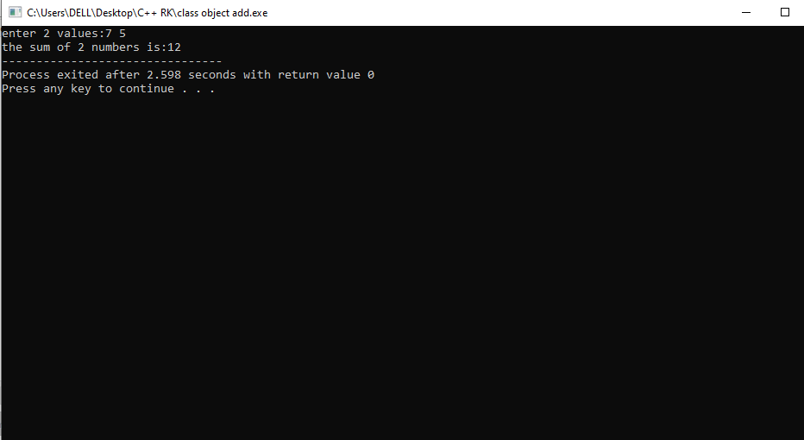

2. WAP in C++ to check the biggest of three numbers using class and object

PROGRAM-

#include <iostream>

using namespace std;

class biggest

{

int a,b,c;

public:

void getdata();

void putdata();

};

void biggest::getdata()

{

cout<<"enter the 3 values:";

cin>>a>>b>>c;

}

void biggest::putdata()

{

if((a>b) && (a>c))

{

cout<<"the greatest number is:"<<a;

}

else if((b>a) && (b>c))

{

cout<<"the greatest number is:"<<b;

}

else

{

cout<<"the greatest number is:"<<c;

}

}

int main()

{

biggest e;

e.getdata();

e.putdata();

}

OUTPUT-

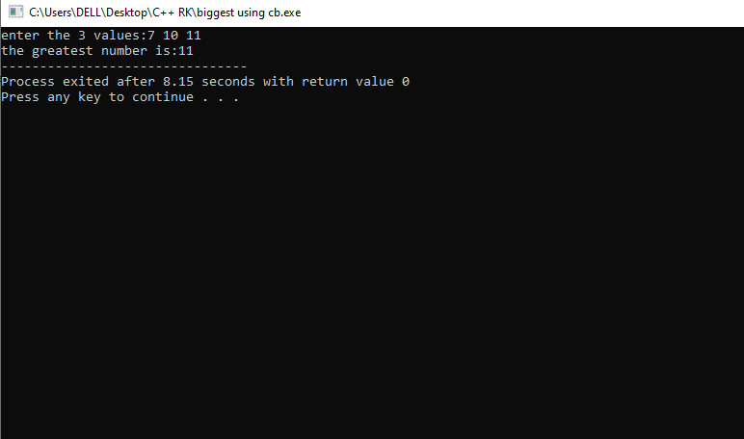

3. WA in C++ for function overloading

PROGRAM-

#include <iostream>

#include<conio.h>

using namespace std;

class go

{

int a,b,c,e;

float d,f;

public:

void getdata();

void display();

};

void go::getdata()

{

cout<<"enter the values for a,b,e:";

cin>>a>>b>>e;

cout<<"enter the value of d:";

cin>>d;

}

void go::display()

{

void sum(int a,int b);

{

c=a+b;

cout<<c<<endl;

}

void sum(float d, int e);

{

f=d+e;

cout<<f;

}

}

int main()

{

go G;

G.getdata();

G.display();

}

OUTPUT-

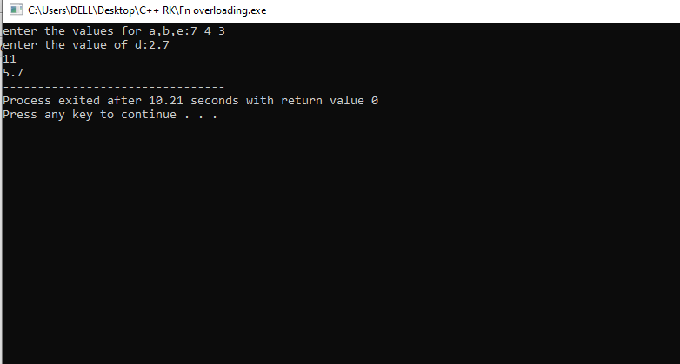

4. WAP in C++ to perform arithmetic operations using switch case

PROGRAM-

#include <iostream>

using namespace std;

int main()

{

int add,sub,muul,div,power,a,b,opp;

cout<<"/n1.addition\n2.substraction\n3.multiplication\n4.division\nenter the operator:";

cin>>opp;

cout<<"enter 2 values:";

cin>>a>>b;

switch(opp)

{

case 1:

cout<<"the addition of 2 no.s is:"<<a+b;

break;

case 2:

cout<<"the substraction of 2 no.s is:"<<a-b;

break;

case 3:

cout<<"the multiplicatiion of 2 no.s is:"<<a*b;

break;

case 4:

cout<<"the division of 2 no.s is:"<<a/b;

break;

default:

cout<<"invalid operation";

break;

}

return 0;

}

OUTPUT-

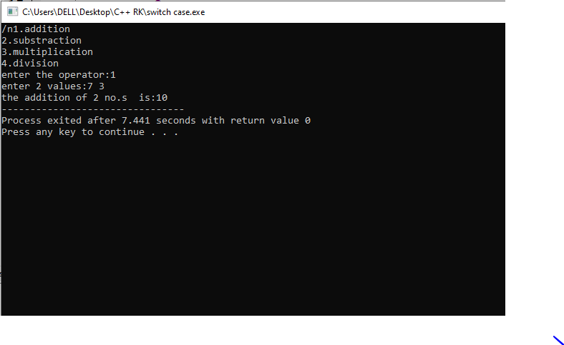

5. WAP in C++ to prepare student report using class and object

PROGRAM-

#include<iostream>

using namespace std;

class marksheet

{

int reg_no,m1,m2,m3,total;

char name[20];

float avg;

public:

void getdata();

void display();

};

void marksheet::getdata()

{

cout<<"enter the student name:";

cin>>name;

cout<<"enter the registration number:";

cin>>reg_no;

cout<<"enter 3 marks:";

cin>>m1>>m2>>m3;

}

void marksheet::display()

{

if(m1>0 && m1<=100 && m2>0 && m2<=100 && m3>0 && m3<=100)

{

total=m1+m2+m3;

cout<<"\nthe total marks obtained are:"<<total;

avg=total/3;

cout<<"\nthe average is:"<<avg;

if(avg>90)

{

cout<<"\nS grade";

}

else if(avg>80)

{

cout<<"\nA grade";

}

else if(avg>70)

{

cout<<"\nB grade";

}

else if(avg>60)

{

cout<<"\nC grade";

}

else if(avg>50)

{

cout<<"\nD grade";

}

else

{

cout<<"\nFAIL";

}

}

else

{

cout<<"invalid input";

}

}

int main()

{

marksheet M;

M.getdata();

M.display();

}

OUTPUT-

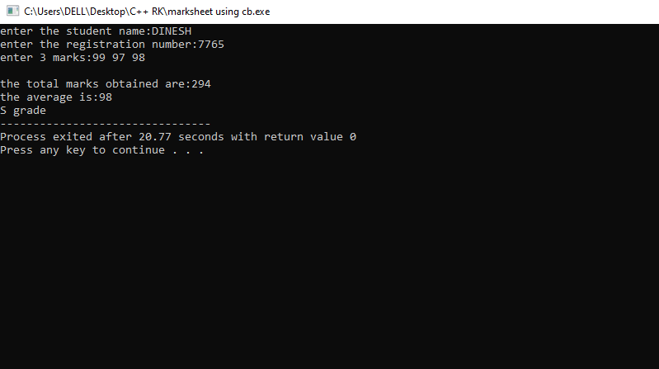

6. WAP in C++ to perform swapping of 2 no.s using class and object

PROGRAM-

#include <iostream>

using namespace std;

class swap

{

int a,b;

public:

void getdata();

void display();

void swapk();

};

void swap::getdata()

{

cout<<"enter 2 no.s";

cin>>a>>b;

}

void swap::swapk()

{

int temp=a;

a=b;

b=a;

}

void swap::display()

{

cout<<"a="<<a<<"tb="<<b;

}

int main()

{

swap s;

s.getdata();

s.display();

s.swapk();

cout<<"nnAfter swap:n";

s.display();

return 0;

}

7. WAP in C++ to check whether the given number is integer or not

PROGRAM-

#include<iostream>

using namespace std;

int main()

{

cout<<"enter the number:\n";

float n;

cin>>n;

int res=n/1;

if(n<=0 || n>=0 && res*1==n)

{

cout<<"\nentered value is an integer";

}

else

{

cout<<"\nentered value is not an integer";

}

return 0;

}

OUTPUT-

